|  |  |
| --- | --- |
|  | Автономное учреждение  среднего профессионального образования  Ханты-Мансийского автономного округа - Югры  **«Сургутский политехнический колледж»**  **Структурное подразделение – 4**  **ЭНЕРГЕТИЧЕСКОЕ ОТДЕЛЕНИЕ** |

**Методические рекомендации**

**по выполнению практических работ по разделу «Электричество»**

**ОГСЭ. 03 «Иностранный язык»**

для обучающихся очной формы обучения

Специальность: 13.02.11 «Техническая эксплуатация и обслуживание электрического и электромеханического оборудования»

Наименование профиля: технический

|  |  |  |  |
| --- | --- | --- | --- |
|  | Должность | Фамилия/подпись | Дата |
| **Разработал** | Преподаватель | Лашина Л.П. |  |
| **Проверил** | Руководитель МО | Донских И.В. |  |
| **Согласовал** | Методист колледжа | Мирошниченко И.В. |  |

Сургут 2016

Английский язык. Методические рекомендации по выполнению практических работ по дисциплине ОГСЭ.03 «Иностранный язык» по разделу «Электричество» для студентов 2 курса специальности 13.02.11 «Техническая эксплуатация и обслуживание электрического и электромеханического оборудования»

Сургутский политехнический колледж. Структурное подразделение 4, 2016г.

Составитель: преподаватель английского языка Л.П.Лашина

Одобрено на заседании методического объединения «Иностранный язык»

Протокол № от « » __________ 2016г.

Рекомендовано к печати Методическим советом Сургутского

политехнического колледжа

Протокол № от « » __________ 2016г.

**Содержание**

|  |  |
| --- | --- |
| 1. Пояснительная записка | стр. 3 |
| 1. UNIT 1.Vocabulary Section (Тематический словарь) | стр. 5 |
| 1. UNIT2. Reading and Speaking Practice Section (Практика устной и письменной речи) | стр. 7 |
| 1. UNIT3. Presentation (Презентация) | стр. 10 |
| 1. APPENDIXES (Приложения) | стр. 12 |
| 1. Список использованной литературы | стр. 17 |

**Пояснительная записка**

Методические рекомендации по выполнению практических работ по дисциплине ОГСЭ.03 «Иностранный язык» предназначены для преподавателей и студентов технических специальностей средних профессиональных учебных заведений. Данные рекомендации составлены с учетом с учётом формирования индивидуальной образовательной траектории учащихся и в соответствии с рабочей программой учебной дисциплины ОГСЭ.03 «Иностранный язык», разработанной на основе Федерального государственного образовательного стандарта профессионального образования.

Цель пособия – последовательно провести студентов по разделам специальной лексики, сформировать навыки работы с технической литературой по специальности и помочь овладеть умением высказываться на иностранном языке по вопросам, связанным с будущей профессией.

Пособие состоит из 3 частей, изучение, которых должно быть последовательно. Используются современные аутентичные материалы, адаптированные для студентов технического профиля по разделу «Электричество». Специальная лексика вводится по темам и закрепляется в разнообразных упражнениях.

Разделы включают в себя следующие задания: дать ответы на вопросы к тексту, заполнить пропуски подходящей по смыслу лексикой, перевести словосочетания и термины, составить монологическое высказывание по предлагаемым для обсуждения темам с обязательным использованием лексики занятия.

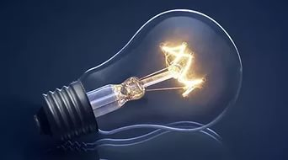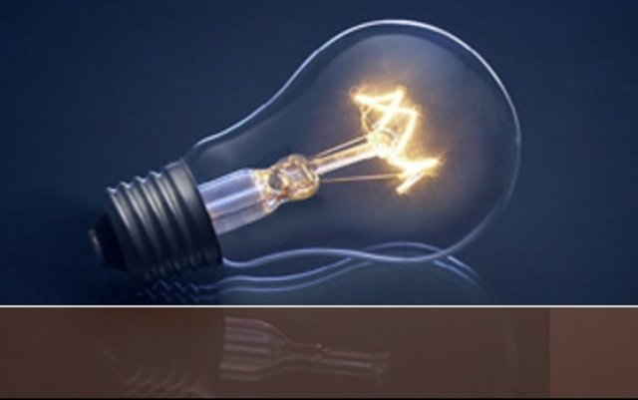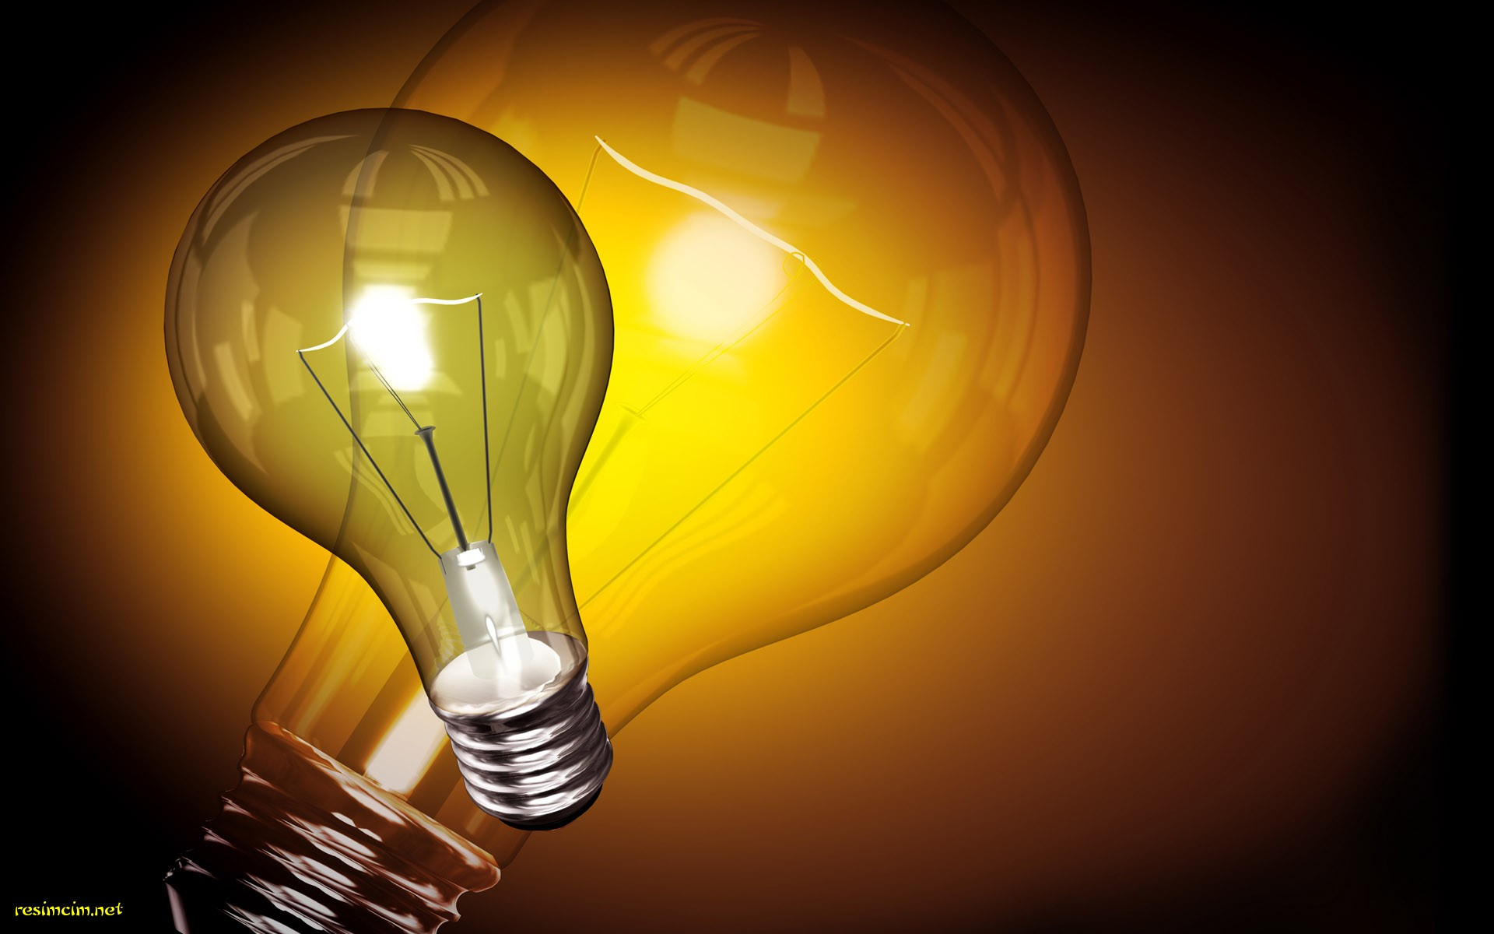

**UNIT 1.Vocabulary Section**

**1) application** *n*  применение

**2) lightning** *n*  молния

**3) longstanding**  *adj* давнишний, долголетний, многолетний

**4) replace** *v* заменить

**5) shaft** *n*  шахта

**6) gear wheel** зубчатое колесо, шестерня

**7) belt** *n*  пояс, лента конвейера

**8) pulley** *n*  шкив, подъемный блок, ролик

**9) appliance** *n* приспособление, электроприбор

**10) device** *n*  устройство, приспособление, прибор

**11) property** *n*  свойство

**12) source** *n*  источник

**13) invent** *v* изобретать

**14) induction motor** индукционный двигатель

**15) consumption** *n* потребление

**16) by-product** *n*  побочный продукт

**17) efficient** *adj* квалифицированный, умелый, эффективный

**18) technological advance** технический прогресс

**19) beam** *n* луч, пучок лучей

**20) provide** *v*  обеспечивать, снабжать, предоставлять

**21) capture**  *v* захватить, собирать, фиксировать

**22) solar cell** солнечная батарея

**23) charge** *v,n* заряжать; заряд

**24) research**  *n* исследование

**25) turn**  *v* поворачивать

**26) produce** *v* производить, изготовлять создавать; порождать;

**27) maintain** *v*  поддерживать, обслуживать; содержать в исправности

**28) harness** *v*  запрягать, использовать, делать полезным, управлять

**29) steam** *n*  пар

**30) water vapor** водяной пар

**31) particle** *n* частица

**32) release** *n,v* избавлять, освобождать, освобождение, выход

**33) droplet** *n* капля

**34) substance** *n* вещество

**35) humidity** *n*  влажность

**36) approach** *n* подход

**37) thunderstorm** *n* гроза

**38) substantial** *adj*  существенный, важный, реальный

**Vocabulary Tasks**

**Exercise 1. Translate sentences into Russian. Make questions to the underlined words.**

1. During the day the student will also use some electrical devices working in the laboratory, making use of the telephone, the lift, the tram and so on.

2. Some people are more familiar with the various applications of electricity in their everyday life than they are with its numerous industrial applications.

3. The energy sources of the world decreasing, the scientists must find new sources of energy.

4. Lightning is a discharge of atmospheric electricity.

5. It is quite possible that some day coal and other fuel may be replaced by atomic energy.

**Exercise 2. Make sentences from the words.**

1. application, the, the, the, technological, of, electricity, contributes, industrial, progress, to.

2. day, use, every, do, appliances, you, electrical?

3. are, longstanding, of what, applications, electricity?

4. induction, who , motor, invented?

**Exercise 3. Insert the words into sentences: *invention, property,******technological advance****,* ***consumption, replace, lightning.***

1. The industrial application of the electric current contributes to the --- .

2. Many years ago a man discovered that many substances have --- either attract or repel other ones when rubbed together.

3. It is quite possible that some day coal and other fuel may --- by atomic energy.

4. Scientists’ --- will help people avoid lightning strikes.

5. Some people don’t like to be out during the thunderstorm and --- .

6. --- of electricity has greatly increased recently.

**Exercise 4. Match**

**- verb+noun**

capture a battery

make electricity

harness a research

discharge sunlight

**- adjective+noun**

tiny humidity

substantial particles

airborne benefit

microscopic substances

high droplets

**Exercise 5. Form the following nouns from verbs using suffixes: *-or; -er(or); -ist; -(i)ation; -ment, - ance.***

Present, imagine, invent, provide, produce, prevent, maintain, involve, confirm, accumulate.

**Exercise 6. Translate the following sentences into English.**

1. Какие свойства электрического тока вы знаете?

2. В мастерских 19 века рабочие использовали зубчатые колеса, подъемные блоки, ремни и другие приспособления для передвижения предметов.

3. Потребление электричества в современном мире растет с каждым годом.

4. Неправильно думать, что при потреблении электричества образуется много побочных продуктов.

5. Вчера на занятии мы читали текст о магнитной индукции.

6. Много лет назад люди научились защищать дома от грозы и молнии.

**TRICKY WORDS**

**Exercise 1. Learn the meaning of the verb TURN и его сочетания с послелогами:**

**Turn**

**1**. поворачивать(-ся) ; вращать(-ся) ; обёртывать; переворачивать(-ся); загибать; закручивать; направлять (тж. внимание, усилия); нацеливать (on, upon); огибать; обходить; обдумывать (вопрос, проблему); превратить; превратиться; заворачивать; кружить; обогнуть; ворочать.

**2.** (как *глагол-связка***) –** делаться, становиться;

**to turn red** - стать красным, покраснеть;

**3. (***фраз. гл.***) turn on -** включать;

**turn off -** выключать;

**turn about** 1) повернуться кругом; 2) повернуть кругом; 3) изменить своё мнение на противоположное;

**turn aside 1**) уклоняться, не поддерживать; 2) обойти, нейтрализовать;

**turn away** 1) прогонять, не пускать;2) обойти, нейтрализовать; 3) отклонять (что-л.); 4) не сочувствовать (кому-л.), отворачиваться (от кого-л.);

**turn back -** возвращаться, поворачиваться назад;

**turn in** 1) лечь спать; 2) возвращать, отдавать, сдавать;

**turn out** 1) выворачивать (карманы и т. п.); 2) оказываться;

**turn up** 1) подшивать (платье, брюки и т. п.); 2) прибавлять (газ, свет),усиливать (звук); 3) неожиданно появляться.

**Exercise 2. Insert the missing words in the right form.**

1*.*When the famous singer appeared at the theatre, crowds of people --- , for lack of room.

2. They --- their way--- as they understood that it was useless trying to find him.

3. You must --- your uniform when you leave the army.

4. He --- an excellent actor.

5. Wait a minute, please, I haven’t finished ---- your trousers yet.

6. All faces --- towards him as he rose.

7. Don’t forget --- the light when you go out.

8. When autumn comes all leaves on the trees --- yellow and red.

9. She softly --- the handle of the door.

**UNIT2. Reading and Speaking Practice Section**

**1. Guess the meaning of the international words:**

electrical motor, electrochemistry, energy, generate, transform, transmission, photocopying machine, dynamo, cable.

**2. Match the English names of electrically operated devices with their Russian equivalents:**

washing machine фен

vacuum cleaner утюг

fridge кухонный комбайн

microwave (oven) посудомоечная машина

electric shaver/ razor микроволновая печь

iron пылесос

kitchen machine стиральная машина

hairdryer электробритва

dishwasher холодильник

**3. Discuss in small groups the following points (see Appendix 1 on p.12):**

- if you can imagine our life without electricity;

- what electrical devices you use in your every day life;

- what can happen if one day we find ourselves without electricity.

**Text A. Electricity in Our Life** 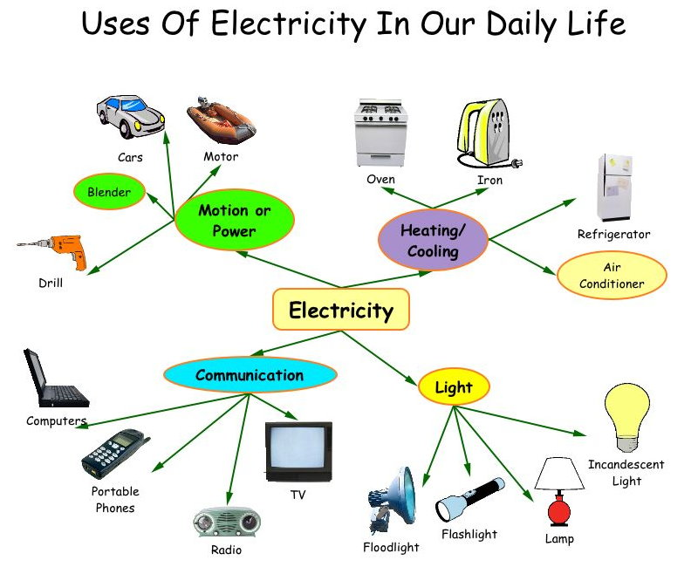

**Read the text to find out about the industrial application of electricity and what one of the greatest advantages of electricity is. Complete the diagram.**

It is impossible to imagine our civilization without electricity: economic and social progress will go back to the past which will completely transform our daily lives. Electrical power has become universal. Thousands of *applications* of electricity such as *lightning,* electrochemistry and electrometallurgy are *longstandin*g and unquestionable.

With the appearance of the electrical motor power cables *replaced* transmission *shafts, gear wheels, belts* and *pulleys* in the 19th century workshops. And in the home a large range of various time and labour saving *appliances* have become a part of our everyday life. Other *devices* are based on the specific *properties* of electricity: electrostatics in the case of photocopying machine and electromagnetism in the case of radar and television. These applications have made electricity most widely used.

The first industrial application was in the silver workshops in Paris. The generator – a new compact *source* of electricity- was also developed there. The generator replaced the batteries and other devices that a man had used before. Electric lightning came into wide use at the end of the last century after Thomas Edison had developed the electric lamp. Then the transformer was *invented*, the first electric lines and networks were set up, dynamos and *induction* motors were designed. In the beginning of the 20th century the successful development of electricity began throughout the industrial world. The *consumption* of electricity has doubled every 10 years.

Today consumption of electricity per capita is an indicator of the state of development and economic state of a nation. Electricity has replaced other sources of energy as it has been realized that it offers improved service and reduced cost. One of the greatest *advantages* of electricity is that it is clean, easy-regulated and generates no *by-products.* Applications of electricity now cover all fields of human activity from house washing machines to the latest laser devices. Electricity is the *efficient* source of some of the most recent *technological advances* such as the laser and electron *beams*. Truly electricity provides mankind with the energy of the future. 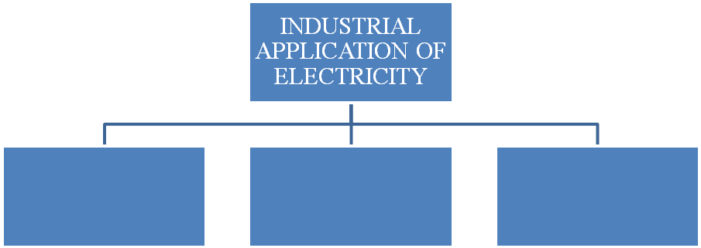

**Practice 1. Find in the text names of all devices that make our lives easier and say which of them are electrically operated and which are manual.**

**Practice 2. Which device:**

- transforms electrical energy into mechanical energy?

a) iron b) telephone c) motor

- lifts objects weighing hundreds of tons?

a) electric crane b) electric furnace c) vacuum cleaner

- lights your room?

a) blender b) lift c) lamp

- is based on electromagnetism?

a) TV-set b) washing machine c) dish washer

- helps people to pull things?

a) photocopying machine b) electric shaver c) electro carrier

**Practice 3. Re-read the text and choose a suitable heading for each paragraph from the list below. One heading is too many.**

1. Due to many devices our life has become easier.

2. Modern civilization needs more and more electricity.

3. Modern people can’t do without electricity.

4. Electricity is widely used in the industrial world.

5. Electricity is the main source of energy.

**Practice 4. Find the wrong statements and correct them.**

1. We use few electrical devices in our life.

2. Appearance of electrical motor contributed to the replacement of manual devices by the power cable.

3. Electrostatics and electromagnetism are the specific properties of electricity.

4. Electricity is the worst source of energy because of bad service and high cost.

5. Electricity has no great advantages.

**Practice 5. Make a short summary of the text using the headings of the paragraphs from Practice 3 as a plan.**

**Practice 6. Make up a dialogue.**

One student thinks that we can’t do without electricity, the other is sure that it’s quite possible. Give as many arguments and counter- arguments as you can think of. Use formulas of agreement and disagreement **(see Appendix 1 on p.12).**

**Text B. Electricity Collected from the Air Could Become the Newest Alternative Energy Source**

**Consider the title of the text. Read the text to find out about the new ways of harnessing the electric energy.**

Imagine devices that *capture* electricity from the air ― much like *solar cells* capture sunlight ― and using them to light a house or *recharge* an electric car. Imagine using similar panels on the rooftops of buildings to prevent lightning before it forms. Strange as it may sound, scientists already are in the early stages of developing such devices, according to a report *presented* at the 240th National Meeting of the American Chemical Society (ACS).

"Our *research* could pave the way for *turning* electricity from the atmosphere into an alternative energy source for the future," said study leader Fernando Galembeck, Ph.D. His research may help explain a 200-year-old scientific riddle about how electricity is *produced* and discharged in the atmosphere. "Just as solar energy could free some households from paying electric bills, this promising new energy source could have a similar effect," he *maintained.*

"If we know how electricity builds up and spreads in the atmosphere, we can also *prevent* death and damage caused by lightning strikes," Galembeck said, noting that lightning causes thousands of deaths and injuries worldwide and millions of dollars in property damage.

The notion of *harnessing* the power of electricity formed naturally has tantalized scientists for centuries. They noticed that sparks of static electricity formed as steam escaped from boilers. Workers who touched the *steam* even got painful electrical shocks. Famed *inventor* Nikola Tesla, for example, was among those who dreamed of capturing and using electricity from the air. It's the electricity formed, for instance, when *water vapor* collects on microscopic *particles* of dust and other material in the air. But until now, scientists lacked adequate knowledge about the processes involved in formation and release of electricity from water in the atmosphere, Galembeck said.

Scientists once believed that water droplets in the atmosphere were electrically neutral, and remained so even after coming into contact with the electrical charges on dust particles and droplets of other liquids. But new evidence suggested that water in the atmosphere really does pick up an electrical charge.

Galembeck and colleagues confirmed that idea, using laboratory experiments that simulated water's contact with dust particles in the air. They used tiny particles of silica and aluminum phosphate, both common airborne substances, showing that silica became more negatively charged in the presence of high humidity and aluminum phosphate became more positively charged. High humidity means high levels of water vapor in the air ― the vapor that condenses and becomes visible as "fog" on windows of air-conditioned cars and buildings on steamy summer days.

"This was clear evidence that water in the atmosphere can accumulate electrical charges and transfer them to other materials it comes into contact with," Galembeck explained. "We are calling this 'hydroelectricity,' meaning 'humidity electricity'."

In the future, he added, it may be possible to develop collectors, similar to the solar cells that collect the sunlight *to produce* electricity, to capture hydroelectricity and route it to homes and businesses. Just as solar cells work best in sunny areas of the world, hygroelectrical panels would work more efficiently in areas with high humidity, such as the northeastern and southeastern United States and the humid tropics.

Galembeck said that a similar *approach* might help prevent lightning from forming and striking. He envisioned placing hygroelectrical panels on top of buildings in regions that experience frequent *thunderstorms*. The panels would drain electricity out of the air, and prevent the building of electrical charge that is released in lightning. His research group already is testing metals to identify those with the greatest potential for use in capturing atmospheric electricity and preventing lightning strikes.

"These are fascinating ideas that new studies by ourselves and by other scientific teams suggest are now possible," Galembeck said. "We certainly have a long way to go. But the benefits in the long range of harnessing hydroelectricity could be *substantial."*

(“*Science Daily*”, August 2010**)**

**Practice 1. Who is this text intended for?**

**Practice 2. Choose the main idea of the article from the following.**

1. Lightning is a dangerous natural phenomenon killing a lot of people.

2. Galembeck’s idea that water in the atmosphere can accumulate electrical charges and transfer them to other materials it comes into contact with turned out to be true.

3. Modern scientists are trying to find ways of harnessing hydroelectricity for the benefit of people.

4. Scientists found new evidence that water in the atmosphere picks up an electrical charge.

**Practice 3. Re-arrange the sentences in logical order.**

1. Developing the idea of hydroelectricity collector might help prevent lightning from forming and striking;

2. Thinks it may be possible to develop collectors to capture hygroelectricity and route it to homes and businesses.

3. Gamelbeck thinks that it’s not so easy and quick to solve the problem of harnessing hydroelectricity but he is sure it will benefit people.

4. Galembeck and colleagues confirmed the idea that water droplets in the atmosphere weren’t electrically neutral using laboratory experiments.

5. Scientists have been trying to find the way of harnessing electricity for centuries.

6. Fernando Galembeck is trying to understand how electricity is produced and discharged in the air.

**Practice 4. Give your own ideas of a device which would be able to accumulate electricity from the air and how it would work.**

**Practice 5. Make a review of the article (see Appendix 2 on p.13).**

**Text C. Is lightning good or bad?**

**Read the text and write a letter to your friend to tell him/her what interesting facts you’ve learnt.**

The intensity of lightning is tremendous. When we hear noises on our radio we conclude that a storm is occuring somewhere in the country. It is not really the case. Similar disturbances have been heard on radio in New York, San Francisco, and elsewhere. It has been proved, moreover, that a powerful flash of lightning in the jungle of India or over the South States suffices to produce disturbances on every radio throughout the world.

Lightning performs some very useful services for mankind. Every stroke of lightning produces some quantity of nitric acid from the nitrogen, hydrogen, and oxygen of the air. About 100,000 tons of nitric acid are produced in this way each year. It is more than man can produce nitrogen by the artificial process.

**UNIT3. Presentation**

**1. Find the information in the text about the contribution of the famous British physicist Michael Faraday to the world science.**

One of a blacksmith's 10 children, Michael Faraday was born on Sept. 22, 1791, in Newington, Surrey. The family soon moved to London, where young Michael picked up the rudiments of reading, writing, and arithmetic. At the age of 14 he was apprenticed to a bookbinder and bookseller. He read ravenously and attended public lectures, including some by Sir Humphry Davy.

Faraday's career began when Davy, temporarily blinded in a laboratory accident, appointed Faraday as his assistant at the Royal Institution. With Davy as a teacher in analytical chemistry, Faraday advanced in his scientific apprenticeship and began independent chemical studies. By 1825 he discovered benzene and had become the first to describe compounds of chlorine and carbon. Faraday had done some work in magnetism and electricity, and it was in this field that he made his most outstanding contributions. His first triumph came when he found a solution to the problem of producing continuous rotation by use of electric current, thus making electric motors possible. Hans Oersted had discovered the magnetic effect of a current, but Faraday grasped the fact that a conductor at rest and a steady magnetic field do not interact and that to get an induced current either the conductor or the field has to move. On Aug. 29, 1831, he discovered electromagnetic induction. During the next 10 years Faraday explored and expanded the field of electricity. In 1834 he announced his famous two laws of electrolysis. He also invented the voltameter, a device for measuring electrical charges, which was the first step toward the later standardization of electrical quantities. Faraday continued to work in his laboratory, but his health began to deteriorate and he had to stop work entirely in 1841. Almost miraculously, however, his health improved and he resumed work in 1844. He began a search for an interaction between magnetism and light and in 1845 turned his attention from electrostatics to electromagnetism. He discovered that an intense magnetic field can rotate the plane of polarized light, a phenomenon known today as the Faraday effect. In conjunction with these experiments he showed that the magnetic line of force is conducted by all matter. Those which were good conductors he called paramagnetics, while those which conducted the force poorly he named diamagnetics. Thus, the energy of a magnet is in the space around it, not in the magnet itself. This is the fundamental idea of the field theory.

Faraday was a brilliant lecturer, and through his public lectures he did a great deal to popularize science. Shortly after he became head of the Royal Institution in 1825, he inaugurated the custom of giving a series of lectures for young people during the Christmas season. This tradition has been maintained, and over the years the series have frequently been the basis for fascinating, simply written, and informative books. On Aug. 25, 1867, Faraday died in London. Michael Faraday was possibly the greatest experimentalist who ever lived.

([*http://blogs.people.co.uk*](http://blogs.people.co.uk))

**2. Prepare a short presentation on one of the problems given below (see Appendix 4 on p. 17)**

1. Famous Russian physicists.

2. New inventions in the field of magnetism.

3. Breeds of dogs and national stereotype.

4. Choosing the right pet.

5. Bird-twitching in Britain.

6. The rescue dogs: myth and reality.

7. The article I’ve recently read.

**IV. Final Activity**

**Visit the link** [***www.izhgsha.ru***](http://www.izhgsha.ru)**to find out more about the Department of Electrical Engineering of the Izhevsk State Agricultural Academy.**

**Consider the following points:**

- the history of the faculty;

- the faculty staff;

- the departments of the faculty;

- the total number of students;

- students’ life.

**Present your report in writing (1 page).**

**You can use other additional resources.**

**MISCELLANEOUS**

**Poem on the History of Electricity**

By Ann Kabat

Luigi Galvani, Italy 1737-1798, anatomist

While dissecting a dead frog he accidentally made a closed circuit. Yes, he made a cell using a muscle tissue, brass and iron. What a shocker when the frog ‘jumped’- okay maybe it’s leg just twitched. Anyway, based on his observations Galvani thought that electricity came from the tissue and as such called it “animal electricity”.

**BUT beware…there was another man with a different explanation**

**Can you imagine their discussion?**

There was…..

electrified air in the room at science fair

where Galvani’s and Volta’s

spark electric signals all in vain.

By the sea, under an olive tree,

A top Mount Vesuvius, in the heart of Rome and Naples…..

to no abate they led long exciting debate

their charged ideas attracted and

in resolving the mystery of an electric s

And so it went… animal, or metal ?

they argued who is right and mighty

in discovering the true source of electricity.

**Alessandro Volta (1745-1827) opposed Galvani’s idea and proposed that the new source of electricity comes from metals, he called it “metallic electricity”.**

**So who was right?**

**APPENDIXES**

**Appendix 1.**

**Speech Patterns**

|  |  |
| --- | --- |
| **Group discussion:**  If you ask me ...  Wouldn't you say that ...  Don't you agree that ...  AsI see it ...  I'd like to point out that ...  I sometimes think that ...  Would you agree that ...  Do you think it's right to say that ...?  I didn't quite follow what you mean, I'm afraid.  I don't quite see what you mean, I'm afraid.  I don't quite see what you are getting at. | **Expressing and reacting to opinions**  True ... but ...  This is my way of looking at it.  I think it goes further than that ... a lot further.  Yes, you're right.  Well, you see what I mean.  That's one way of looking at it. But ...  Yes, if you like ...  You may be right ... All the same ...  Just a minute ...  Come off it ...  James thinks that ...  In Margaret's opinion ...  Margaret feels that ...  His view is ... |
| **Agreement**  Yes, Iagree entirely here.  I couldn't agree more.  You know, that's exactly what I think.  Yes, that's true.  That's my way of looking at it too.  What you say is perfectly true.  It goes without saying that ...  I fully agree.  I am of the same opinion.  It really looks like that.  I won't deny that.  That's a fine way of putting it.  That's a good point.  That's just what I was thinking. | **Disagreement**  There may be something in what you say but ...  It's not at all the same thing.  I see your point but ...  You don't seem to realize that ... but that's not the point...  Not in the least!  Just the other way round!  I can't possibly ...  I shouldn't say so.  I've got some reasons to disagree.  I've got an argument to oppose.  On the surface of it really is ... but ...  On the one hand ... On the other hand ...  Well, I'm not so sure. Well, I wouldn't go quite that far ...  I wouldn't say that exactly. It might be right but...  That's totally unfounded.  You can't be serious. |

**Appendix 2**

**Аннотирование публицистического текста**

**Аннотация**

Аннотация – предельно сжатое, краткое изложение главного содержания текста. Основным отличием аннотации от реферата является то, что последний дает представление о содержании оригинала, тогда как аннотация – только о его тематике. Аннотация перечисляет вопросы, проблемы оригинала, но не ставит целью их раскрыть их.

Для аннотации характерно использование специальных оборотов, клише.

**Структура аннотации**

1. Предметная рубрика (область/раздел знания, к которым относится аннотируемый материал.)
2. Тема
3. Выходные данные источника
4. Содержание аннотации.

**Клише и связующие слова для рефератов и аннотаций к публицистическим текстам**:

1. first of all/ for a start – прежде всего, во-первых
2. besides – кроме того, помимо этого
3. moreover – более того
4. in addition to – в дополнение к этому
5. on the one hand – с одной стороны
6. on the other hand – с другой стороны
7. however – однако, тем не менее
8. in spite of this/that – несмотря на
9. according to – по словам, согласно
10. therefore - следовательно
11. thus - таким образом
12. finally/ eventually/ in the end – в конечном итоге
13. in conclusion – в заключение

**При написании используйте следующие клише:**

1. The article/text under review….. Рассматриваемый нами текст …
2. The article is entitled…. Текст озаглавлен …
3. The headline of the article/text is… Заголовок статьи/ текста…
4. The author of the text is… Автор данной статьи…
5. This article/text deals with… Данная статья /текст рассматривает…
6. It is devoted to… Он/она посвящены….
7. The author describes different ways…Автор предлагает разные способы/пути…
8. The author comes to the conclusion Автор приходит к мнению…
9. The author underlines that… Автор подчеркивает…
10. The article/text focuses on… Статья/текст сосредоточены на…
11. Attention is paid to… Внимание уделяется….
12. The article/text attempts to clarify… В статье делается попытка….
13. It is shown that… Показано, что…
14. Data are presented on… Представлены данные о том, что…
15. Attempts are made to analyze… Сделана попытка проанализировать…
16. Conclusions are drawn… Делаются выводы о том, что….
17. Some recommendations are given… Даны рекомендации относительно…

**Пример аннотации текста “Computers, Curriculum and the learning Environment”**

***The scientific article under review is entitled “Computers, Curriculum and the learning Environment”. The author of the article is N. Thompson. It is published in the journal “Computer Education”, volume 16, Number 1, 1991, published in Great Britain.***

***The paper deals with the problems of the effective application of computers in learning.***

***The main idea of the article is to show teachers and tutors that if they combine learning in partnership with technology, they get a more effective and flexible learning system.***

***The author describes 4 different ways which can enhance the learning environment: by making learning more practical and more provisional, by improving the learners’ access to learning and by increasing the focus on higher order skill.***

**Appendix 3**

**Рекомендации к оформлению личного письма**

1. Адрес отправителя представляет заглавную строчку в начале письма в правом верхнем углу. В адресе не должно быть никаких знаков препинания. Сначала указывается номер дома, затем название улицы, город и код: *38 Manor Way Dyfed DY7 9SH.*

2.Дата приводится сразу после адреса отправителя. Например: *9 April 2011.*

3. Письмо начинается с обращения. После обращения ставится запятая. Варианты обращения:

*Dear John,*

*Dear Aunt Jane,*

4. В начале письма Вы выражаете благодарность за ранее полученное письмо:

*Thank you for your letter*..., *Many thanks* *for..., I was glad to get your letter..., How nice of you* *to*..., etc*.*

5. Далее следует извиниться, если вы долго не писали:

*Sorry, I haven't written for so long...,* *I must apologize for not writing..., I really should have written sooner...,* etc*.*

6. Далее следует основное содержание письма.

Начальные фразы письма:

*How are you?*

*I'm writing to ask for...*

*I'm writing to tell you that we are going to be in Providence during Christmas time.*

*I'm writing to ask you if you would come to dinner/lunch …etc.*

При написании письма следует соблюдать абзацы и употреблять слова и фразы, которые часто употребляются и в устном разговоре: *Can you believe it? So you can imagine* *what it was like! Luckily, we didn't...,* *Anyway we are...,* etc*.*

7. В конце письма используются следующие заключительные фразы: *I'т looking forward to hearing from you..., Don't forget to write...,* *I'11 write again soon..., Hope to hear from you soon…,* etc.

8. Завершить письмо можно одной из следующих фраз:

*Lots of love, Love, Best wishes, All the best, Yours*. После этих фраз ставится запятая и следует подпись. Личные письма подписываются без указания фамилии.

Варианты подписи:

*Sincerely yours,*

*Nora*

*With all good wishes,*

*Nora*

*With best wishes,*

*Nora*

38 Manor Way

Dyfed DY7 9SH

4 June 2002

Dear Felix,

I was glad to get your letter. Sorry I didn't get in touch before, but...

_______________________________________________________________________________________________________________________________________________________________________________________________________________________________________

Hope to hear from you soon.

All the best,

Jane

Appendix 4

Making a Presentation

Most presentations are divided into 3 main parts (+ questions):

|  |  |  |
| --- | --- | --- |
| 1 | INTRODUCTION | Questions |
| 2 | BODY |
| 3 | CONCLUSION |
|  | Questions |

Introduction

The introduction is a very important - perhaps the most important - part of your presentation. This is the first impression that your audience have of you. You should concentrate on getting your introduction right. You should use the introduction to:

1. welcome your audience
2. introduce your subject
3. outline the structure of your presentation
4. give instructions about questions

The following table shows examples of language for each of these functions. You may need to modify the language as appropriate.

|  |  |  |
| --- | --- | --- |
|  | Function | Possible language |
| **I IN T R O D U C T I O N**  INTRODUCTION | 1.Welcoming  your  audience | Good morning, ladies and gentlemen  Good afternoon, ladies and gentleman  Good afternoon, everybody |
| 2. Introducing  your subject | I am going to talk today about...  The purpose of my presentation is to introduce our new range of... |
| 3.Outlining your structure | To start with I’ll describe the progress made this year  Then I’ll mention…  After that I’ll consider …  Finally, I’ll summarize my presentation |
| 4. Giving instructions | Do feel free to interrupt me if you have any questions  I'll try to answer all of your questions after the presentation, about questions  I plan to keep some time for questions after the presentation. |
| B O D Y |  | Firstly… Secondly…  To begin, let’s look at  I’d like to emphasize…  Let’s move on… |
| C O N C L U S I O N | 1. Summing up | In conclusion…  Now, to sum up…  So let me summarize |
| 2. Giving recommendations | My recommendations are…  I suggest the following… |
| 3 Thanking your audience | Many thanks for your attention |
| 4. Inviting questions | Now, I’ll try to answer your questions  Are there any questions?  Do you have any questions/ |

Questions are a good opportunity for you to interact with your audience. It may be helpful for you to try to predict what questions will be asked so that you can prepare your response in advance. You may wish to accept questions at any time during your presentation, or to keep a time for questions after your presentation. Normally, it's your decision, and you should make it clear during the introduction. Be polite with all questioners, even if they ask difficult questions. They are showing interest in what you have to say and they deserve attention. Sometimes you can reformulate a question. Or answer the question with another question. Or even ask for comment from the rest of the audience.

(

<http://www.englishclub.com/business-english/presentationspres.htm>)

**Список использованной литературы**

**Книги**

1. Грамматика английского языка в таблицах и схемах. – СПб, ООО «Полиграфуслуги», 2005. – 96 с.

2. Истомина Е.А. Английская грамматика. Теория и практика для начинающих. – М.: «ВЛАДОС», 2004. – 319 с.

3.Филюшкина Л.Т. Сборник упражнений к учебнику английского языка Н.А.Бонк, Н.А.Котий, Л.Г.Лукьяновой /Л.Т.Филюшкина, М.П.Фролова

М.:Междунар.отношения, 1999. – 160 с.

4. Голицынский Ю.Б. Грамматика: сборник упражнений / Ю.Б.Голицинский – СПб.: КАРО, 2003. – 544 с.

5.Raymond Murphy. English Grammar in Use (for intermediate students). Cambridge University Press, 1997.

6. Chris C. Pinney. The Complete Home Veterinary Guide. – New York, 2004. – 340 p.

**Статьи из газет и журналов**

1. Bee Wilson. Real Bread //The Telegraph. – 2010. – 20 July.

2. Andy Bloxham. Junk food is causing pet obesity epidemic// The Telegraph. – 2008. – 20 July.

3. Simon Devin.Plant a Country Garden// Home Farmer. – 2010. – №4. – P. 11 – 12

4. Janice Houghton. Rhubarb//Home Farmer. – 2010. – №6. – P. 9

**Электронные ресурсы**

2. <http://blogs.people.co.uk>